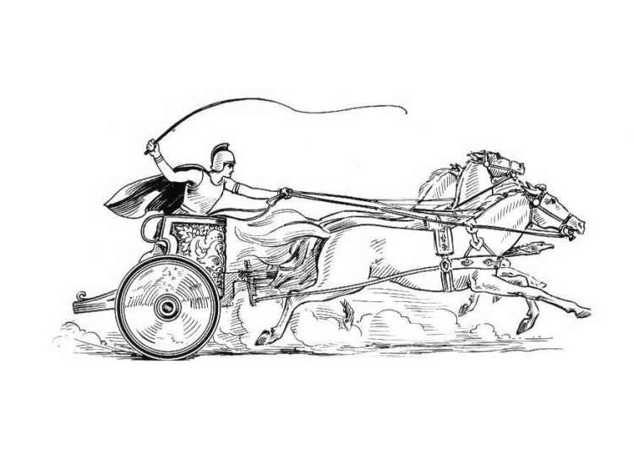

ANNUAL PARISH COUNCIL MEETING
OF THE PARISH OF MANCETTER

Minutes of the Annual Parish Council Meeting of the Parish of Mancetter,
held on Tuesday 24th May 2022 at St Peter’s Church Schoolroom commencing at 7pm.

Present:
Chairman Mr T Hopkins.

Parish Councillors Mr H Blackburn, Mrs G Forknall, Mrs S Healy, Mr P Mann.
Mrs S Dore from Item 3.

County Councillor Mrs M Bell.
Borough Councillor Mr A Clews

Parish Clerk Mrs E Higgins.
Assistant Clerk Finance Mrs K Meads.

Item 1- Appointment of Chair and Vice Chair – Signing of Declaration of Acceptance of office.

Mr H Blackburn as Vice Chair asked for nominations for the role of Chair. Mr T Hopkins was proposed by
Mrs S Healy seconded by Mrs G Forknall and appointed unanimously. Mr T Hopkins signed the declaration
book alongside the Clerk and proceeded to chair the meeting.

Mr H Blackburn was nominated to continue as Vice Chair by Sue Healy seconded by Mr P Mann and
approved unanimously. Harry Blackburn duly signed to accept this office in the presence of Mrs E Higgins.

Item 2 - Co-option to one of two Parish Councillor vacancies as authorised by NWBC Democratic Services. Signing of Declaration of Acceptance of Office, Code of Conduct and Pecuniary Interests.

Mancetter Parish Council received email confirmation from Democratic Services of permission to co-opt to the second councillor vacancy. Mrs S Dore had attended the annual meeting of parishioners in April, chatted to councillors, and received information on eligibility and legal requirements prior to the meeting from the clerk. Sheila Dore signed to accept her office as a parish councillor and code of conduct and pecuniary interests’ forms were completed.

There is one space left on the council, so if any parishioners wish to consider this appointment, then please contact Elane Higgins, the Mancetter Parish Clerk for more information.

Item 3 – Welcome and Apologies.

Mr T Hopkins formally welcomed Mrs S Dore and everyone to the Annual Parish Council Meeting and noted
apologies from parish councillor Nicola Wallis due to pre-arranged leave and borough councillor Mrs D
Clews who had another meeting. These apologies were accepted.

Both borough councillors were due to attend the same meeting, but Mr A Clews sent his apologies and
attended the Mancetter Parish Council meeting instead.

Due to a previous commitment County Councillor Mrs M Bell arrived about 7.30pm to give her update.

A specialist portable air filtration system was plugged in throughout the meeting to provide COVID ventilation to protect councillors and members of the public.

Item 4 – Recording of the meeting.

There was no recording of the meeting.

Item 5 – Notice of Interest.

There were no declarations of interest for this meeting.

Item 6 – Public Question Time.

There were no members of the public present. No issues had been raised with the Clerk prior to the meeting.

Item 7 – Minutes of the last meetings.

The draft minutes from the 22nd March 2022 were proposed by Mrs S Healy, seconded by Peter Mann and therefore formally signed by the chairman as a true record of proceedings.

It was agreed that the review of the draft minutes from the Annual Parish Meeting for Parishioners held on 26th April 2022 be deferred until the next meeting.

Item 8 – Matters arising from the previous minutes.

There were no additional matters arising not already included in the forthcoming agenda points.

- To receive the list of Meeting Dates for the new Parish Council year.

All councillors received and noted a copy of the proposed meeting dates to cover council business up until the beginning of the new term of office in May 2023. This information has also been given to the Police, Borough and County councillors and is displayed on the noticeboards and website.

- Update on Ridge Lane Chapel and Community Room.

Since the last parish council meeting no further developments have come forward from the Methodist Church. They are in the process of considering a change of officer so things are likely to be quiet for the time being. The community in Ridge Lane are becoming more proactive at advertising their community facility with an active Facebook page for the village.

- Update on Community Speed Watch Training, Locations and Signage

Four Parish Councillors, the Clerk and two members of the public have all completed intense training on operating the speed gun, including calibration and record keeping. Two sites have been risk assessed for monitoring. Members of the Mancetter Speed watch communicate by a WhatsApp group and have the necessary signage and equipment and can now go out independently.

Item 9– Feedback from Police.

There may be an issue with the email address of our current PCSO so the Clerk will check the details and verify that it is still Emily Jenkins who covers our area. Only one Constable and two PCSO’s are on duty for the whole of the North Warwickshire area including the outlying villages.

Consequently, there was no police update, although information can be found on the police newsletters distributed online via “Warwickshire Connected” or the “Neighbourhood Watch”.

Item 10- Report from County and Borough Councillors

The tree in Lewis Close causing issues has been felled and the footpath reinstated. A resident in a wheelchair is still experiencing difficulties in safely navigating the dropped kerbs.
A lack of any Enforcement Officers is causing major difficulties in the backlog of Enforcement issues.

Item 11– Finance

- Formal Receipt of Financial Accounts 2021 – 2022.
Proposed by Mr H Blackburn seconded by Mrs G Forknall and approved unanimously.
- Section One of the Annual Governance and Accountability Return the Annual Governance Statement was approved by all councillors and signed by the Chair and Clerk.
- Section Two of the Annual Governance and Accountability Return the Accounting Statements were approved by all councillors and signed by the Chair and RFO.

- Mr T Hopkins and Mrs G Forknall signed the financial paperwork in accordance with the Bank Mandate.

- Daily payment limits have been increased to £1,500 and the Clerk Account now has a zero balance. Due to the requirement of two signatures, a parish council debit card could not be acquired and so the Clerk was authorised to continue using her debit card and reclaim through expenses.

- It was suggested by Trevor Hopkins, proposed by Harry Blackburn and seconded by Sue Healy to approve a payment of £50.00 to Girlguiding Warwickshire to cover refreshment costs for the two annual meetings this year.

- Confirmation of the renewal of WALC membership was noted by Councillors for the forthcoming financial year.

- Following a grant application for a Jubilee event to be held at Mancetter Memorial Hall, it was agreed unanimously to award a grant of £200.00.

- £20.00 can be allocated towards materials for the Lewis Close Memorial Garden Committee if required for shield decoration. It was unanimously approved to purchase 12 x £15.00 Love to Shop vouchers as prizes for community groups taking part in the Jubilee Shield Display.

Item 12– Mancetter Parish Platinum Jubilee Celebrations

On Sunday 29th May all commemorative shields will be displayed on the parish council owned cemetery railings in Mancetter and lamp posts in Ridge Lane.

On Wednesday 1st June Mrs G Forknall and Mrs E Higgins will walk around Mancetter Village putting out the 70 fact Heritage Trail with blank sheets available at the Cemetery and the Memorial Hall.

Item 13 – Review of Statutory Documents, Responsibilities and Membership of Liaison Committees and Working Groups.

- The Mancetter Parish Council Standing Orders were reviewed and updated to reflect the changes in not following European Protocols for Procurement.
- All Councillors submitted new Pecuniary Interests forms to update the NWBC website information.
- Code of Conducts are unchanged as the Borough Council have yet to adopt the 2020 amendments.
- The following membership was agreed for the forthcoming council year:

Sarval Liaison – Mr T Hopkins, Mrs G Forknall
Planning Group – Mr T Hopkins, Mrs S Healy, Mr H Blackburn, Mr P Mann, Mrs S Dore
Quarry Liaison – Mr T Hopkins, Mrs S Healy, Mr P Mann
Road Safety/ Traffic Calming – No change
A5 Contact Group – Mr T Hopkins, Mr P Mann
Climate Change Group – Mrs S Healy, Mr T Hopkins, Mrs G Forknall

- Trevor attended a recent SARVAL meeting where they are looking to increase workforce and productivity capacity and to bring a second bio bed online.
- A Policy working group consisting of Trevor, Sue, Peter and Elane will gradually review the Council policies and procedures bringing proposals back to full council for approval.

Item 14 – Planning Matters and New Applications since the previous meeting.

No new applications had been received and concerns were raised over the lack of enforcement particularly at a local heritage site. It was agreed to invite Steve Maxey and Jeff Brown to a future meeting.

Item 15 – Cemetery and Maintenance around the Parish

- The Purchase of a new bespoke Cemetery Deed book was approved unanimously by the council.
- The Creation of a Scattering area for ashes was agreed and will be looked at in more detail at the next meeting.
- The policy amendment to Cemetery Fees was deferred until the next meeting.

Item 16 – Date of Next Meeting

Tuesday 26th July 2022 7pm at St Peter’s Church Mancetter.

As there was no further business the meeting closed at 10pm.

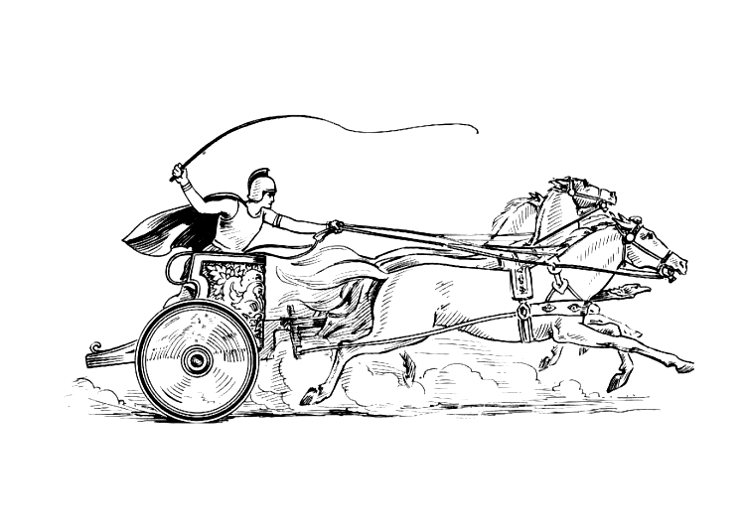

Manduessedum - Mancetter Village
(Place of War Chariots)
Mancetter Parish Council
Serving the People of Mancetter and Ridge Lane.

